1. INstall Jenkins

User: mengu

Pass:manisha

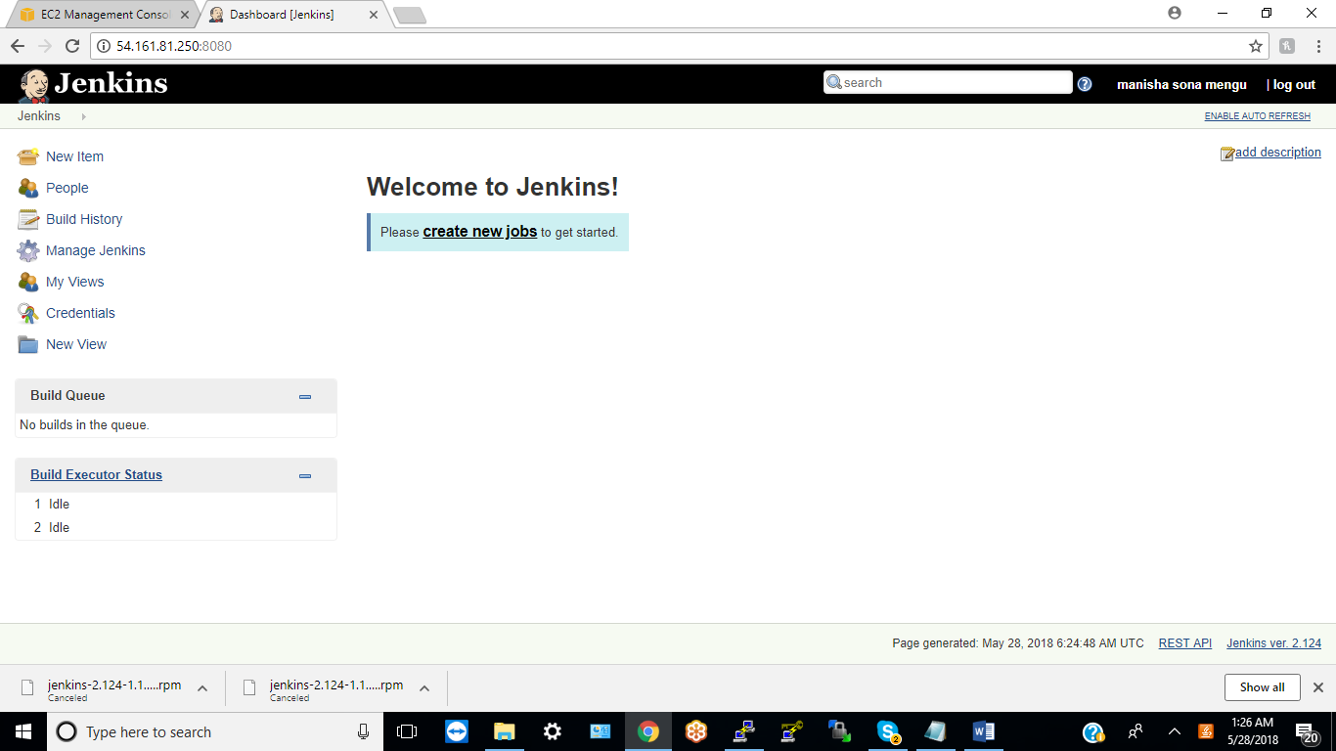

2. Create a jenkins pipleine to deploy a code to an application

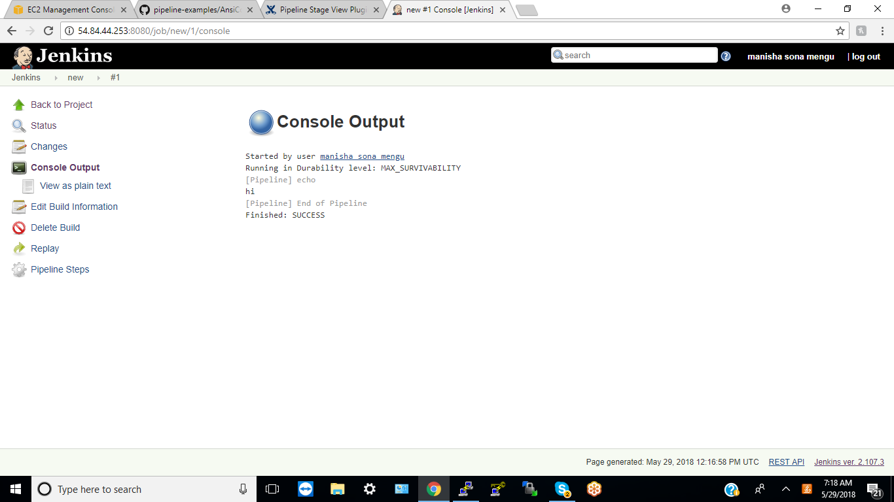

Git Hub link : <https://github.com/manishadevops2020/code>

3. Add a  new slave to the jenkins and execute the same job on the slave

I have added “Slave1”

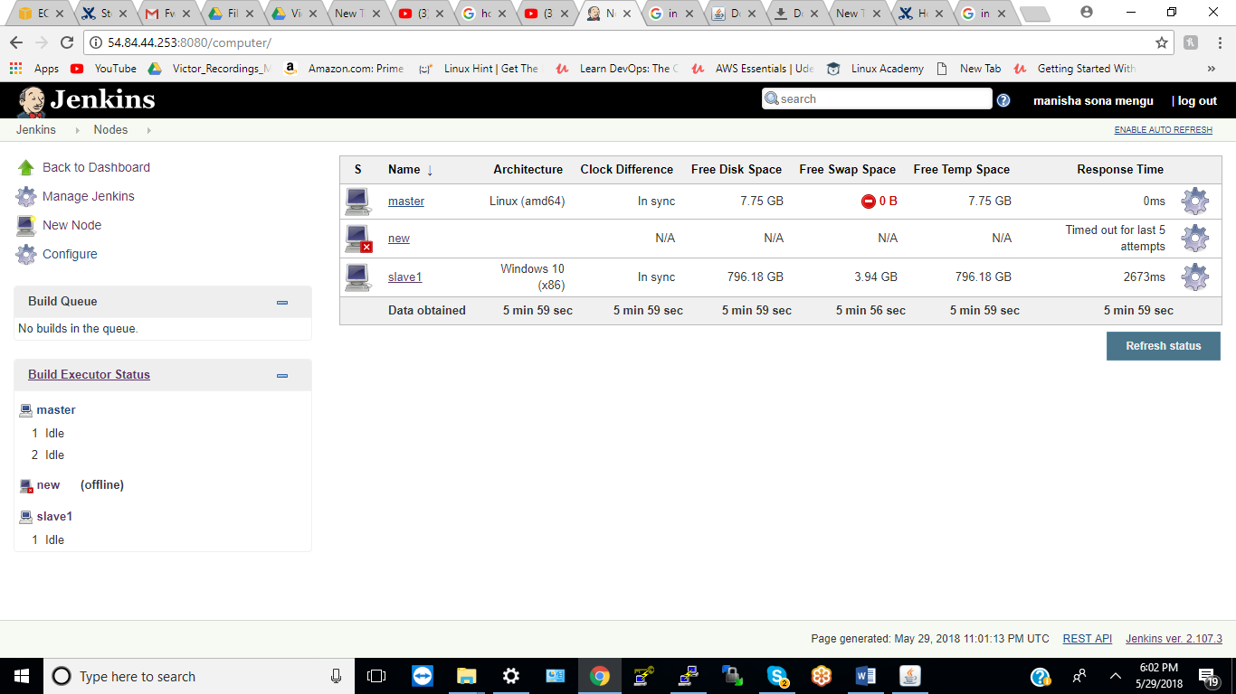

4. Install any 15 plugins in Jenkins

Installed green ball plugin :

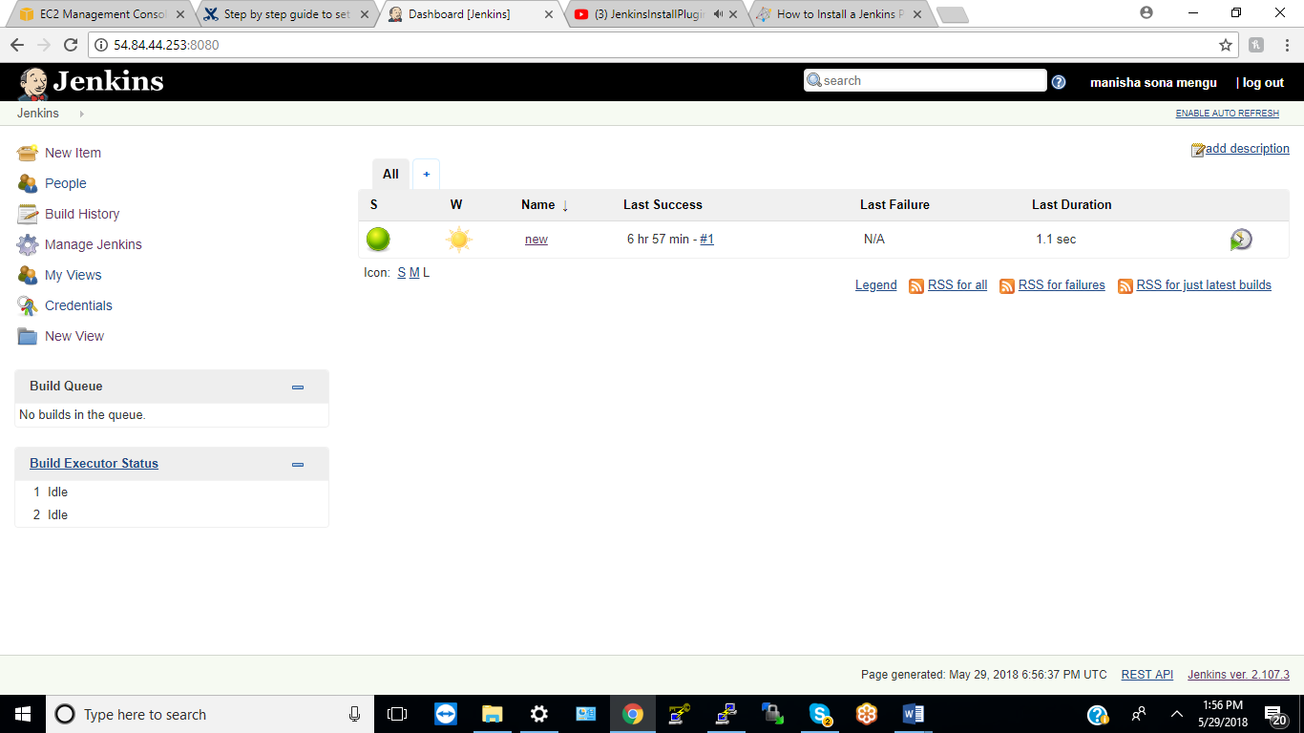

5. Create a kubernetes cluster and deploy cassandra and kafka PODS

6. create a deployment using helm charts and deploy  new code to thesse PODS in step 5

7. Now Create a terraform template to create 4 Ec2 , 3 VPC, 6 RDS instance , 2 CLoud watch alarms  and setup a  ELB with auto scaling group.

Ec2 Instance:

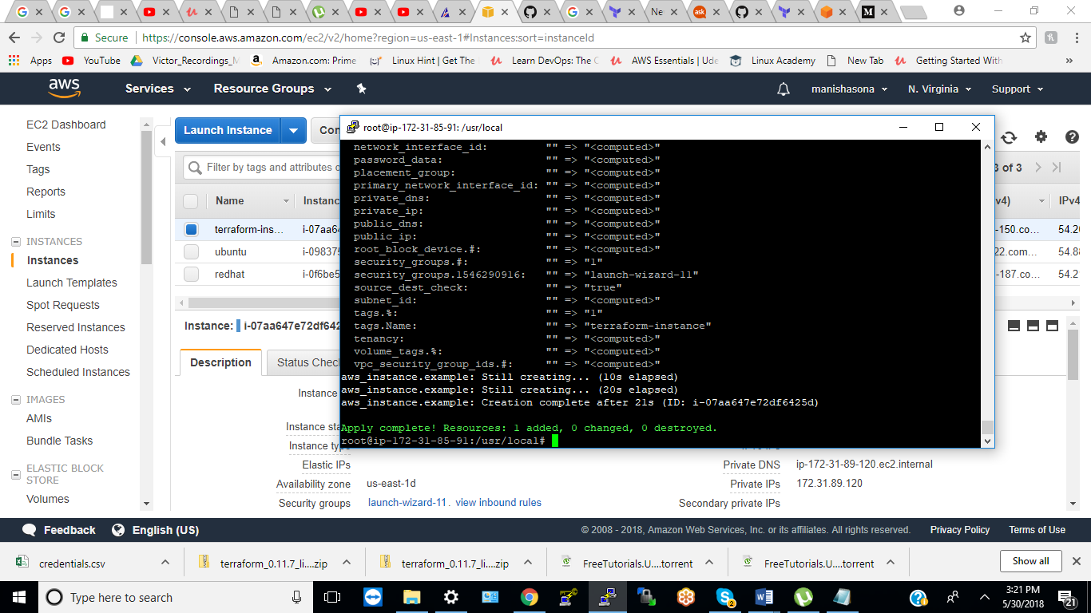

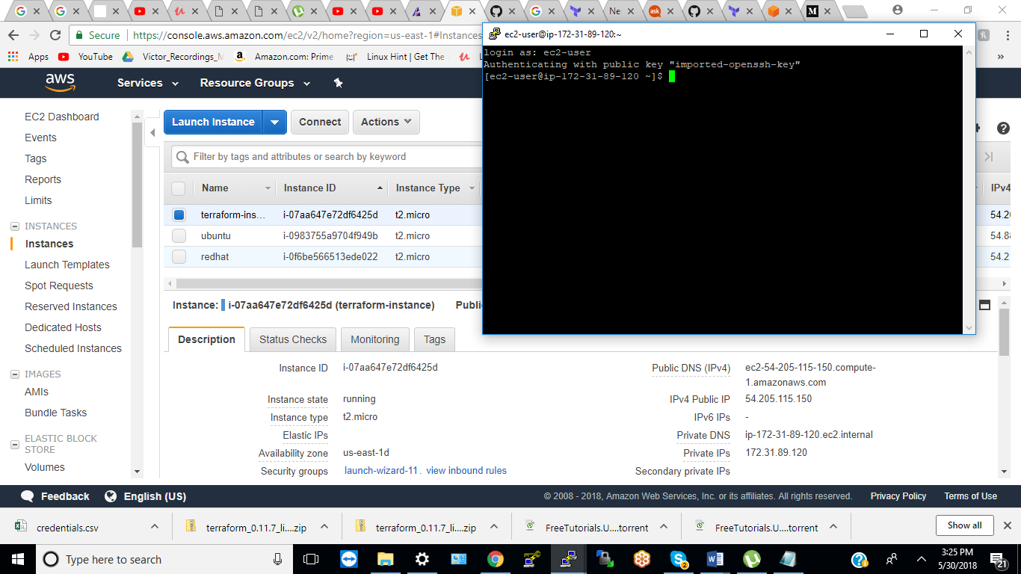

VPC: 1

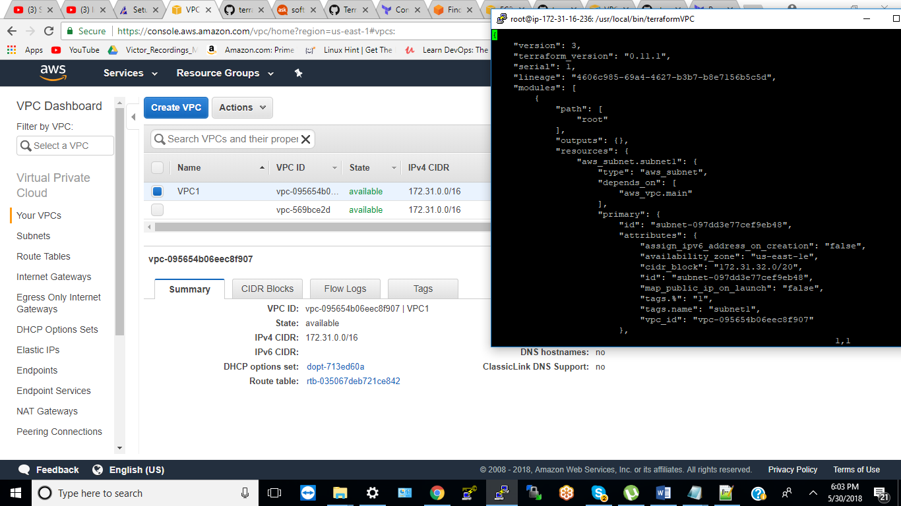

VPC 2:

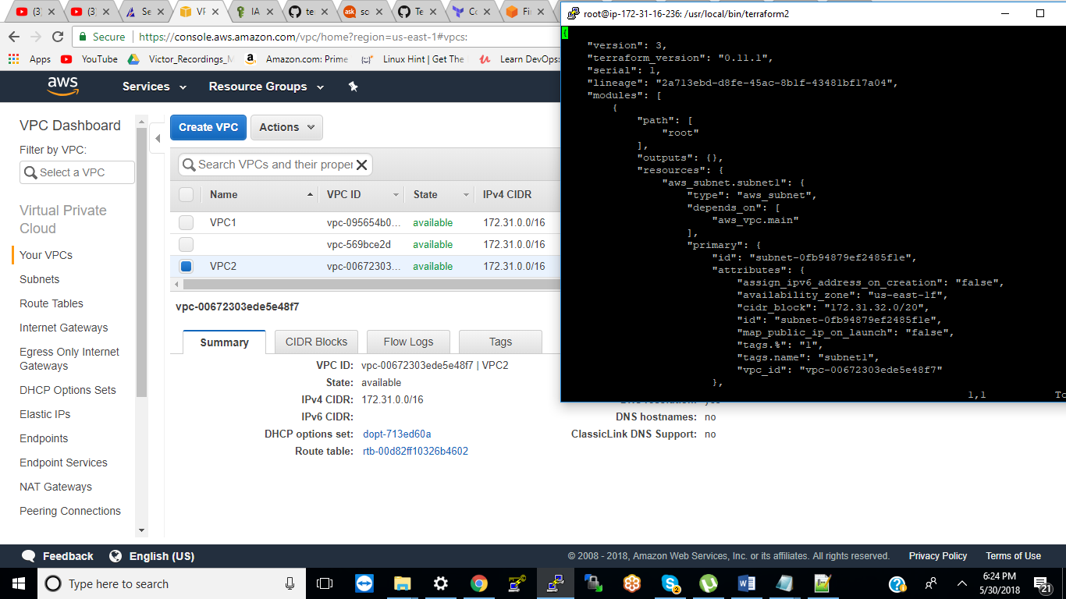

VPC3:

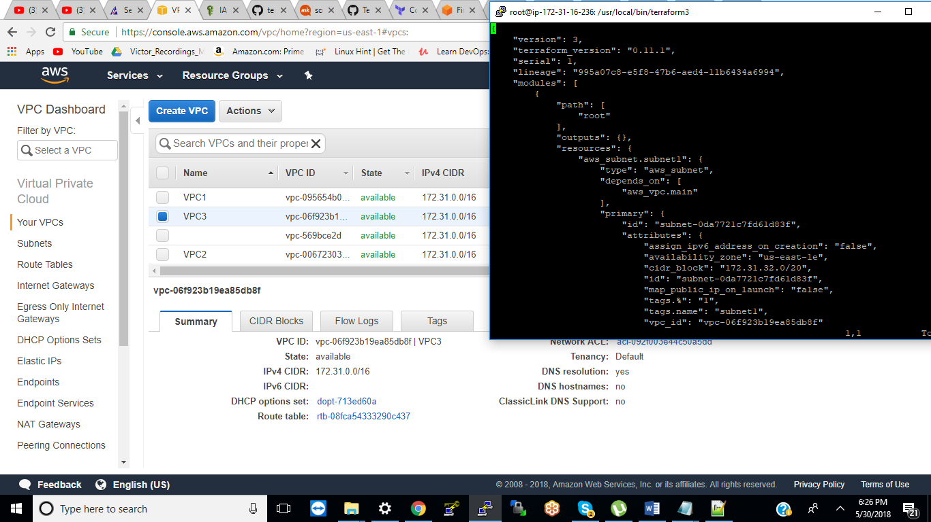

8. now Create 10 python scripts with boto3 to create  any 6 AWS services

EC2 instance using Boto3:

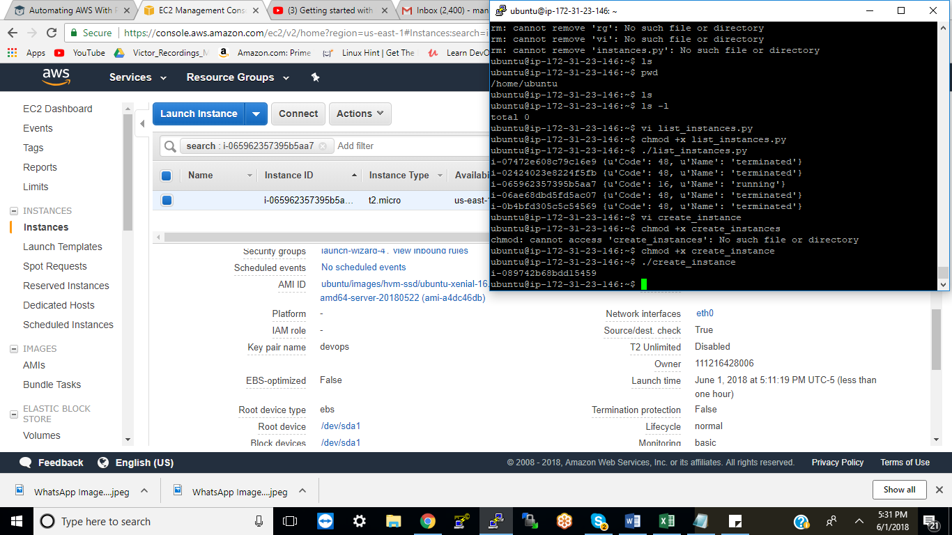  
instance is running :

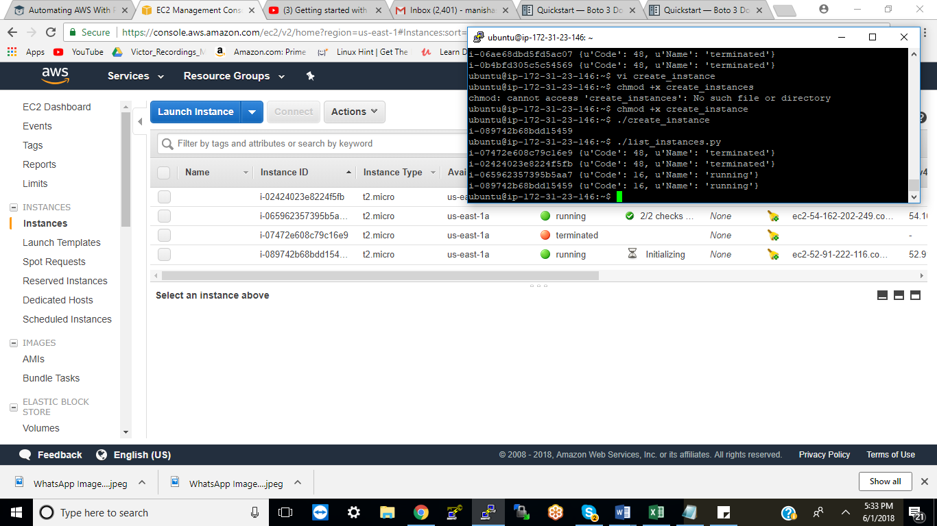

Creating S3 bucket using python Boto3 :

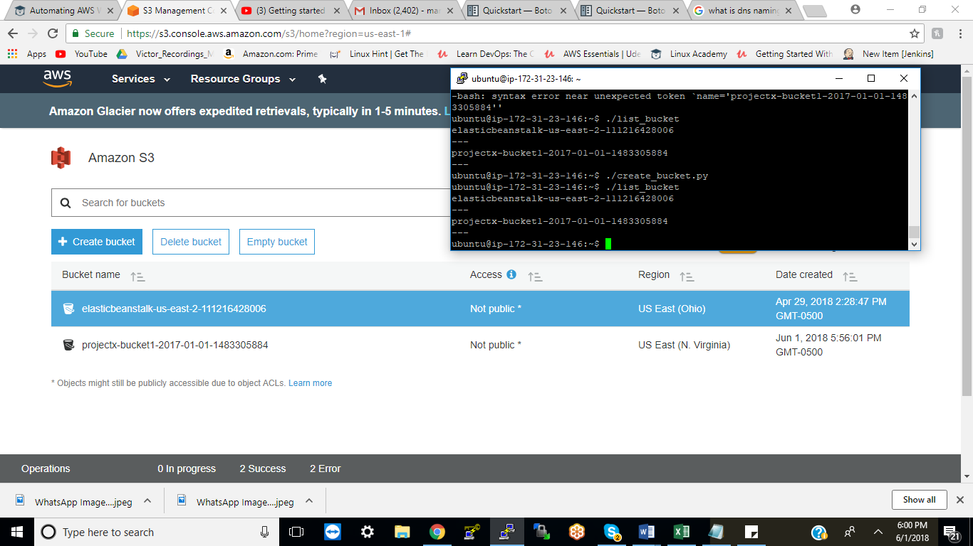

9. now Create  a nginx kubernetes cluster with 8 PODS

10 wtite below Python scripts:

1. write a Python script to add 2 numbers

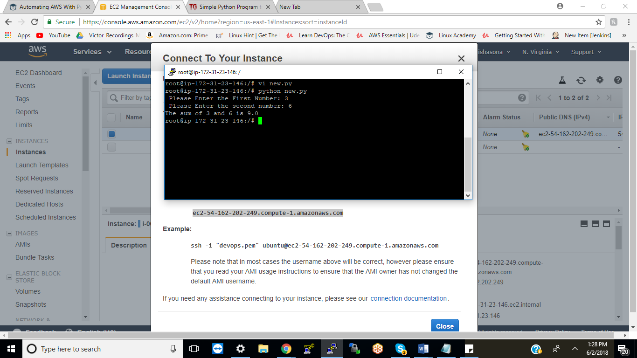

1. python script to  multiplt 2 numbers

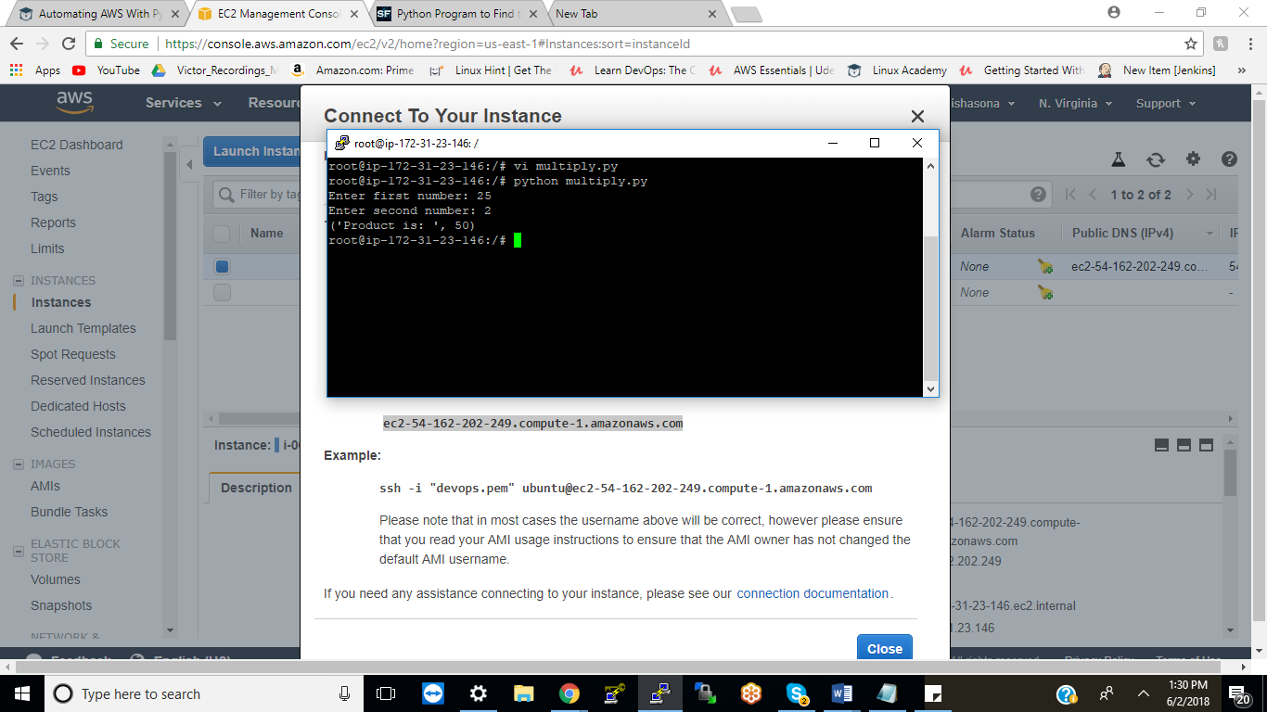

1. sort an array using python

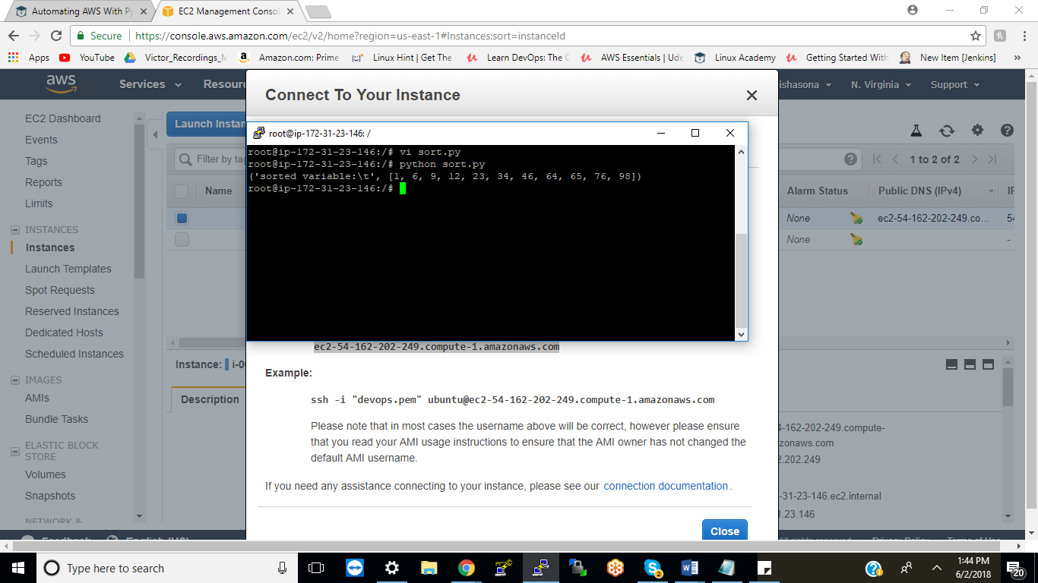

1. sort a list using python

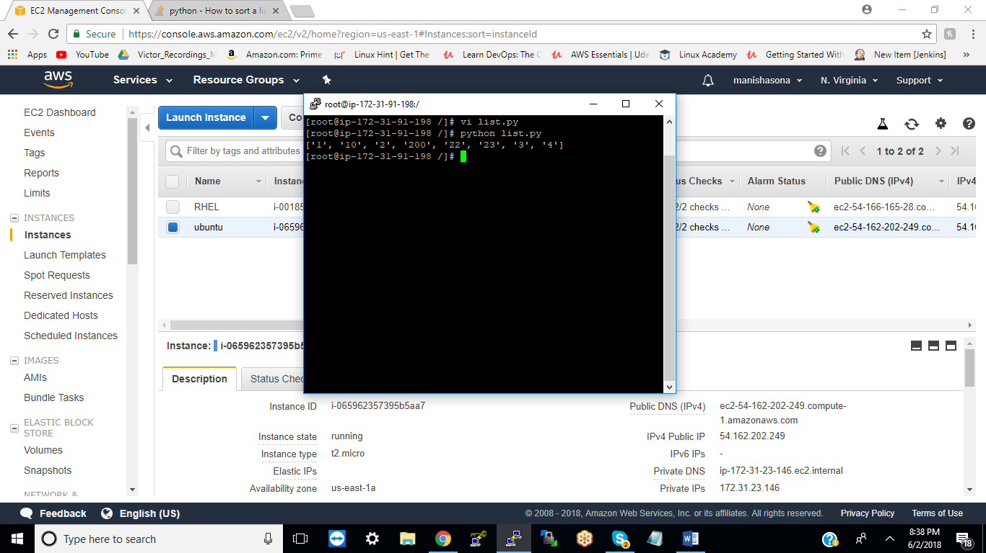

               5. write python script to host a basic web server with apache

1. python script to  install a package  
   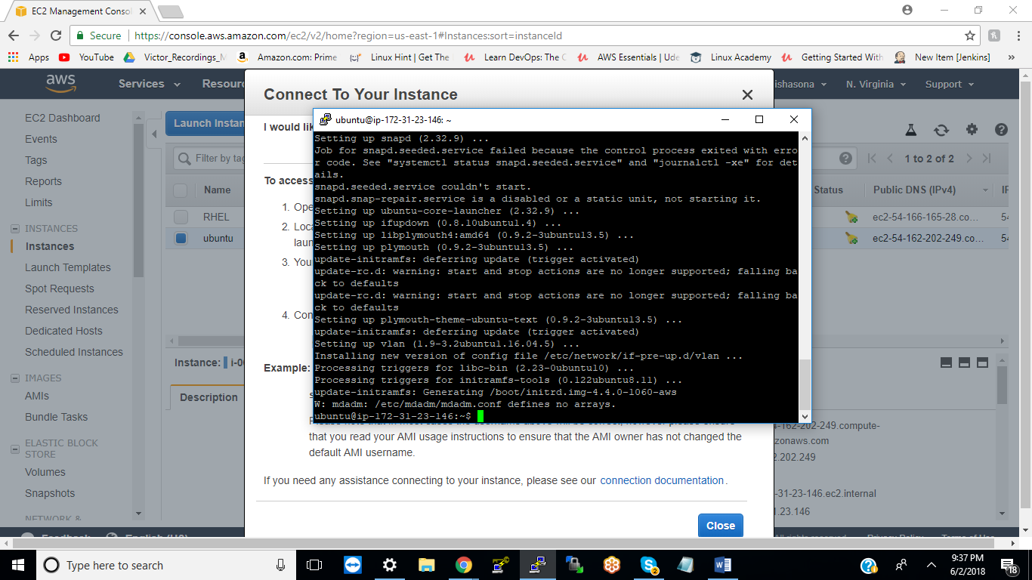
2. python script to create an Ec2 instace

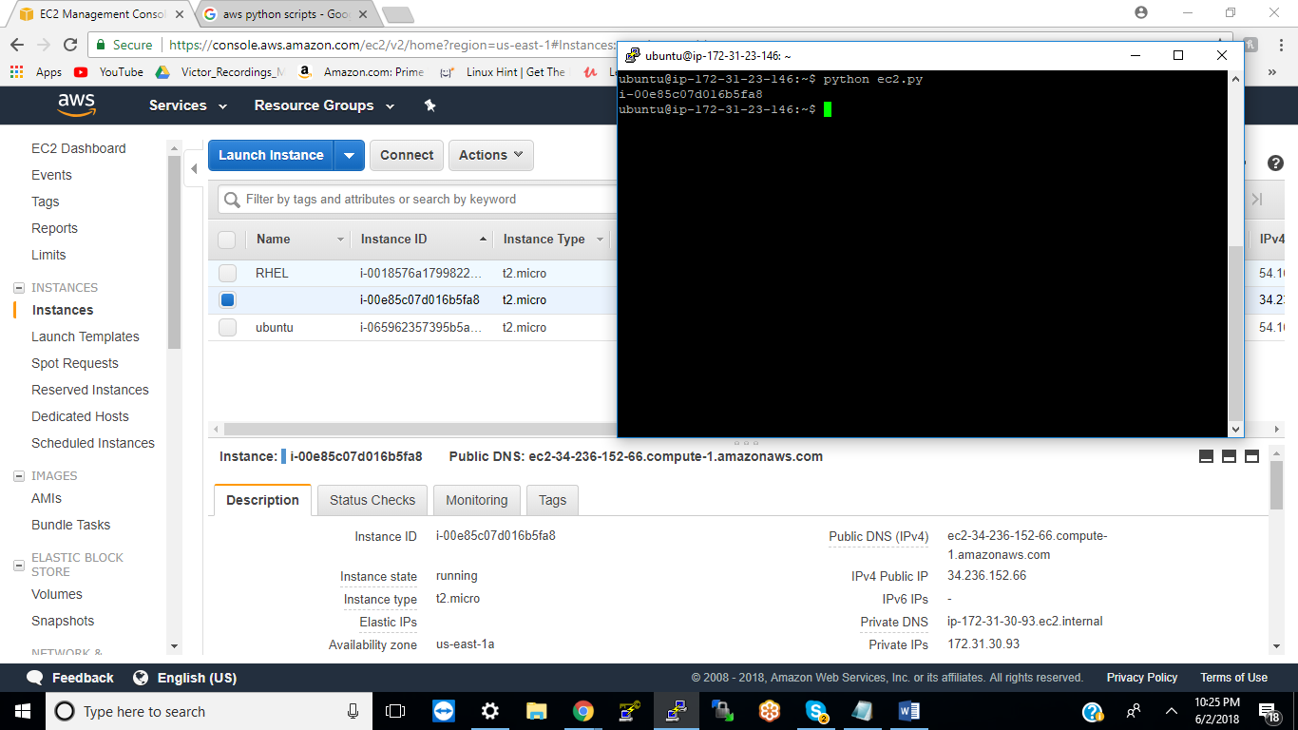

1. Python script to create 10 directories in /tmp called fish1 to fish10

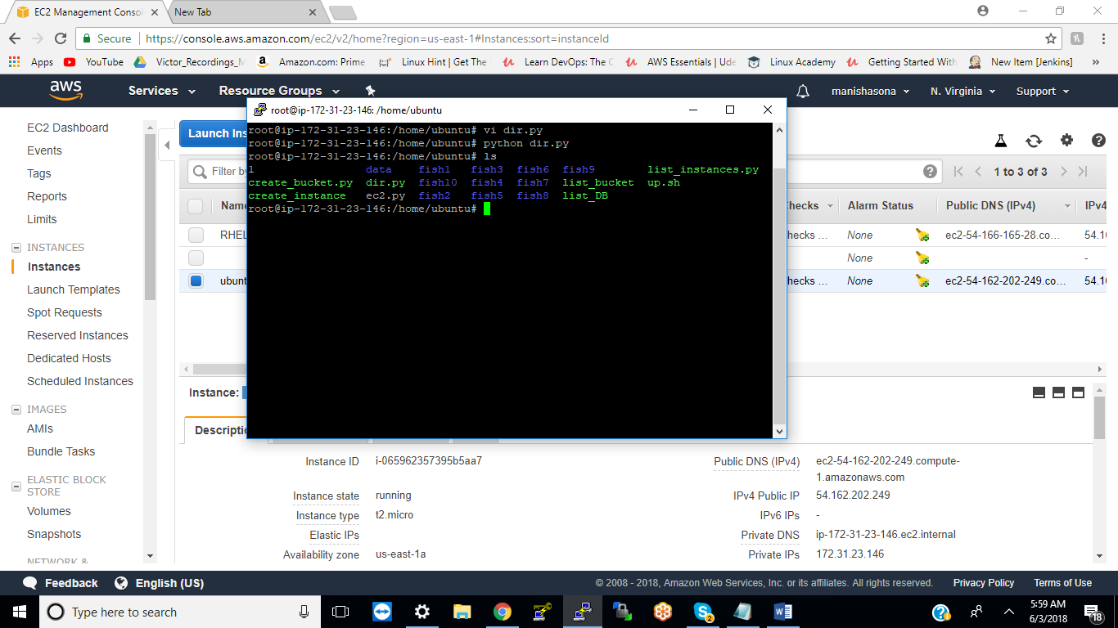

1. python script to explain difference between python 2 and 3?

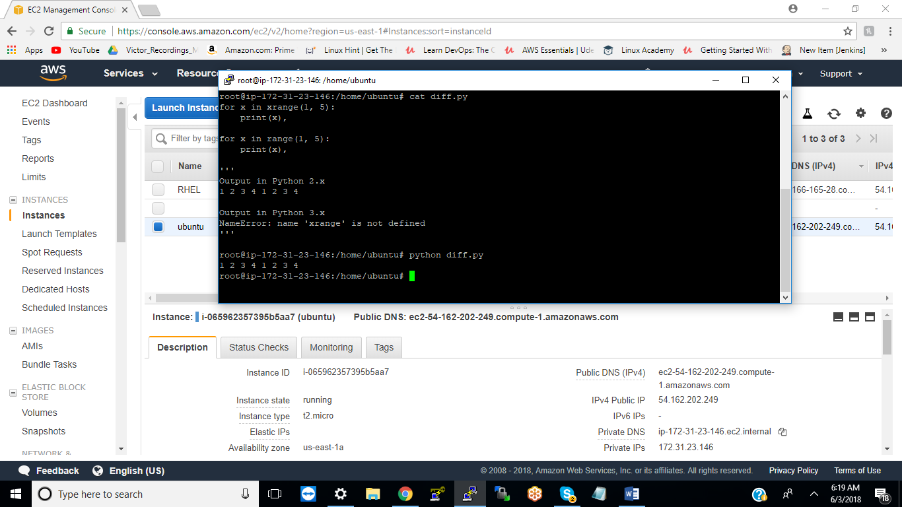

               10. Python script to create 10docker contaiiners /

11. Complete dcoker questions below

               1. try all comands in <https://try.github.io/levels/1/challenges/1>

               2.  Create a github local account

               3. Create a local git repo and add 4 files .

               4.merge it to  central repo

               5. now  modify those 4 files and commit and send it to the repo

               6. now create a new branch  called fish and add 4 more files to fish

               7.now   Create a  new brach called  tank and add 5 more files toit

               8. now demonstrate  the difference  betwene git merge and rebase on fish and tank

               9. now do a git push to remote repo

               10 . now  review git log and observe the changes

               11. now revert back to previous commit and push it to github

               12. now  Create a new branch called goat

               13. now delete goat branch

               14. now  add a new file to github from your desktop

               15. now pull that to the local linxu machine  and  view that file on your linux machine.

12. Execute below commands :

<https://kubernetes.io/docs/tutorials/kubernetes-basics/cluster-interactive/>

13. Create NAgios XI and setup alerting for 10  linxu machines for CPU and memory alerts.